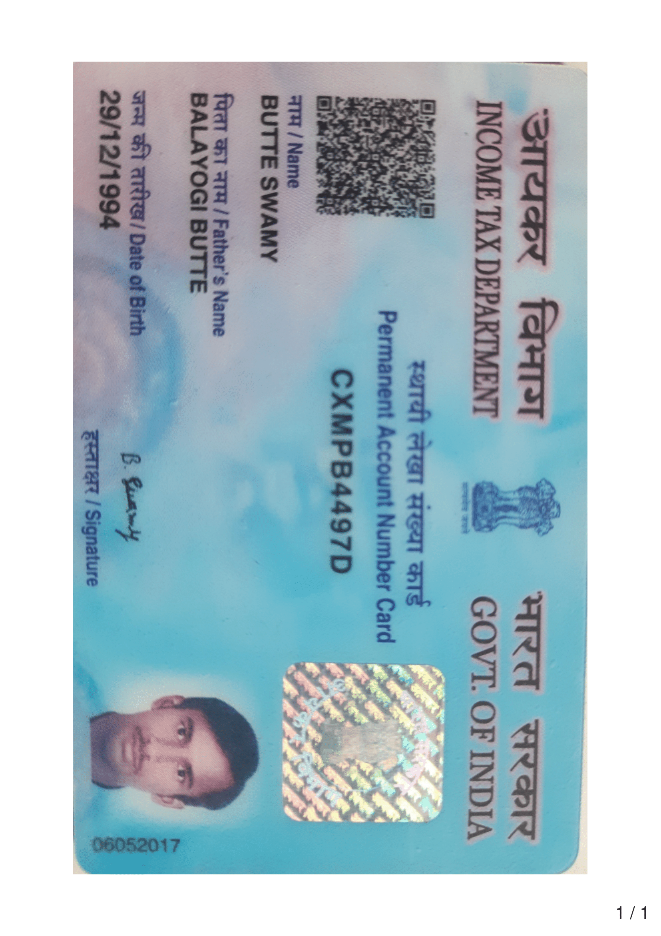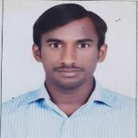
LinkedIn ID: https://www.linkedin.com/in/butte-swamy-65019a138
Butte Swamy
Software Engineer
Email: butteswamy@gmail.com
8919295962

Professional Summary:
- 5.1 years of experience as a software developer in development and implementation of web and client server applications using Microsoft Technologies.
- Hands on in application development using in ASP.NET using .VB Net as the code-behind language and ADO.NET and WPF.
- Extensive experience in design and development of application using .NET and Web technologies like CSS, JavaScript and HTML in n-tier architecture.
- Experience in Tables, Views, Stored Procedures, Functions, Triggers and SQL profiler using MS SQL Server.
- Ability to learn & develop using new technologies quickly.
- Experience in Coding, Debugging and Unit testing in Visual Studio.
- Experience in different phases of project like Requirement Gathering, Application Design, Database Design, Software development Process, Performance tuning, Integration, System Implementation.
- Experience in Handling Critical Client Issues and Provide Support.
- Experience in working with Team Foundation Server (TFS), Jira, Helptxtnow, GIT and Ticketing Tool and Agile framework.
- Experience in working with IIS server and resolving environment and server Issues.
- Experience on Agile methodology.

Technical Skills:
Programming Languages : C#.Net, VB.Net.
Data Access Technologies : ENTITY FRAMEWORKS, ADO.NET
Databases : SQL Server 2017/2018
Web Technologies : HTML, CSS, JavaScript, ASP.NET, ADO.NET, WPF ,react.js
IDEs : Visual Studio2010/2017/2019/2022
Web Server : Internet Information Server
Reporting Tools : Crystal Reports.
Issues Tracking Tools : Jira, Target Process, Helptxtnow
Version Controls : TFS, GitBucket

Education:
B. Tech in the department of Electronics and Communication Engineering (2013-2016) at Sri Prakash College Of Engineering in with 67.56%
Diploma in the department of Electronics and Communication Engineering (2010-2013) at Sri Varalakshmi Polytechnic in Machilipatnam with 75%
S.S.C from Z.P.H. School (2010) in Angara with 78%

Work Experience:
Company Name : Tech Mahindra.
Designation : Software Engineer
Experience : 1.4 Year to till Date

Work Experience:
Company Name : Caliber Technology Private Ltd.
Designation : Sr. Software Engineer Level-3
Experience : 1.3 Years

Work Experience:
Company Name : InteQ software Private Ltd.
Designation : Junior Software Engineer
Experience : 2.6 Years

Projects Handled:
Tech Mahindra:
- CS - APPS
Role: .NET Developer
Clients Handled : In house
Period: 27th Apr 2022 to till now
Technical Environment: ASP.Net, ADO.Net, C#, JavaScript, CSS, HTML, WPF, React.jss
Databases: SQL Server 2017/2018
Team Size: 10

Description:
- Worked on the Corporate Service Application (CS – APPS) is software.
- This is an internal project this project has SSCAD, ID Cards, Vehicle Parking, ARTS/ Access Control.

ID Cards-:
New joiners and existing employees will get soft copy id cards from in this application.
ARTS / Access Control -:
This application will give access permission based on departments and roles. For example, admin employee can be able to access all area based up on the privileges and normal employee can access there working location.

Responsibilities:
- Responsible for understanding the requirements, designing, and developing the application.
- Performing Unit Testing and Bug Fixing.
- Working on live client issues on production.
- Production Support.
Caliber Technology Private Ltd:
2) Laboratory Information Management System (LIMS)
Role: .NET Developer
Clients Handled : Dr.Reddy’s, Hetero, Aurobindo, Ajanta, Amneal and Mylan
Period: 4th Jan 2021 to 26th Apr 2022
Technical Environment: VB.Net, ASP.Net, ADO.Net, C#, JavaScript, CSS, HTML, reactjs
Databases: SQL Server 2017/2018
Team Size: 10

Description:
- This is web-based application. The main purpose of this project is to adopt 100 % without paperless laboratory work and provide data tracking support with flexible architecture
- Fully track and maintain an Audit Trail, assign roles and groups that dictate access to specific data records and who is managing them, Calculate and maintain processing and handling times on chemical reactions, workflows and more.

Responsibilities:
- Used Ado.NET to interact with SQL Server Database.
- Used ASP.Net Validation Controls for server-side validations.
- Used java script validation for compare validation, Regular expression validation.
- Involved in Web development by using HTML, ASP.NET using VB.NET
- Creating the database objects tables, stored procedures, cursors as per the project requirement.
- Working on Client requests SCR’s and MR’s
- Performing Unit Testing and Bug Fixing
- Working on live client issues and provide corrective, preventive actions
- Create and Maintain Documentation for Code changes and SCR’s.

InteQ software Private Ltd:
- EZ-CAP

Role: .NET Developer
Clients Handled : Citra Health Solutions
Period: 18th July 2018 to 31st Dec 2020
Technical Environment: VB.Net, ASP.Net, ADO.Net, C#, JavaScript, CSS, HTML, WPF
Databases: SQL Server 2017/2018
Team Size: 10

Description:
- EZ-CAP is a benefit management platform used by many health organizations which is capable of streaming all invaluable information & critical processes.
- It is a widely used healthcare benefit management solution for Independent Physician Associations (IPAs), Managed Service Organizations (MSOs), Physician-Hospital Organizations (PHOs), Health Plans, and other managed care organizations.

Responsibilities:
- Preparing Design Documents.
- Implementing Database Changes, UI changes (Design the Page Layouts).
- Making the functional changes in the code.
- Issues fixing.
- Releasing Hot fix to QA.
- Production Support.
- Unit Testing.

Personal SKILLS:
- Ability to meet deadlines without compromising accuracy, excellent product quality and attention to detail.
- Excellent technical troubleshooting, code debugging, and problem-solving skills.
- Possess strong organizational and time management skills with a demonstrated ability to work both independently and within a team environment
- Exhibit a high level of professionalism and excellent interpersonal skills
- Strong relationship-building ability, proactive, results-oriented, and resourceful.
- Excellent attention to detail and workflow administration.

Personal details
Date of birth: 29th December 1994
Nationality: Indian
Languages Known: English, Telugu and Hindi

Declaration:
I hereby declare that all details mentioned above are in accordance with the truth and fact as per my knowledge.
Butte Swamy.
Hyderabad.

